**SE – OVERVIEW OF IT INDUSTRY.**

1. **What is software? What is software engineering?**

**ANS.** Software is a program or set of programs containing instructions that provide desired functionality.

Software Engineering is the process of designing, developing, testing, and maintaining software. It is a systematic and disciplined approach to software development that aims to create high-quality, reliable, and maintainable software.

1. **Explain types of software.**

**ANS.**

1.System software:

System software is software that directly operates the computer hardware and provides the basic functionality to the users as well as to the other software to operate smoothly.

1. Operating System
2. Language Processor
3. Device Driver

2. Application Software:

Software that performs special functions or provides functions that are much more than the basic operation of the computer is known as application software.

1. General Purpose Software
2. Customized Software
3. Utility Software
4. **What is SDLC? Explain each phase of SDLC**

**ANS.** The Software Development Life Cycle (SDLC) is a process used by software development organizations to plan, design, develop, test, deploy, and maintain software applications.

PHASE:

1. Requirements gathering and analysis: This phase involves gathering information about the software requirements from stakeholders, such as customers, end-users, and business analysts.
2. 2. Design: In this phase, the software design is created, which includes the overall architecture of the software, data structures, and interfaces. It has two steps:

High-level design (HLD): It gives the architecture of software products.

Low-level design (LLD): It describes how each and every feature in the product should work and every component.

1. Implementation or coding: The design is then implemented in code, usually in several iterations, and this phase is also called as Development

4. Testing: The software is thoroughly tested to ensure that it meets the requirements and works correctly.

5. Deployment: After successful testing, The software is deployed to a production environment and made available to end-users.

6. Maintenance: This phase includes ongoing support, bug fixes, and updates to the software.

**4. What is DFD? Create a DFD diagram on Flipkart**

**ANS.** Flow Diagram (DFD) represents the flow of data within information systems. Data Flow Diagrams (DFD) provide a graphical representation of the data flow of a system that can be understood by both technical and non-technical users.

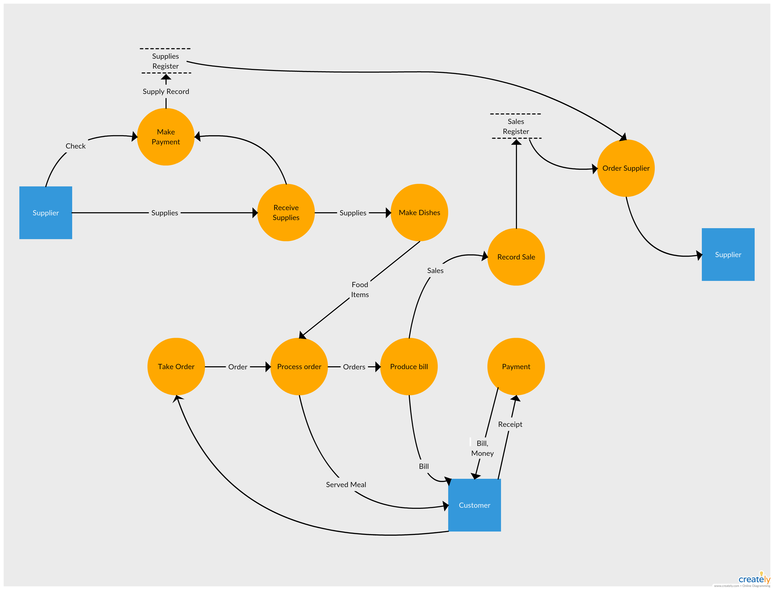

**5.** **What is Flow chart? Create a flowchart to make addition of two numbers**

**ANS.** A flowchart is a type of diagram that represents a workflow or process. A flowchart can also be defined as a diagrammatic representation of an algorithm, a step-by-step approach to solving a task.

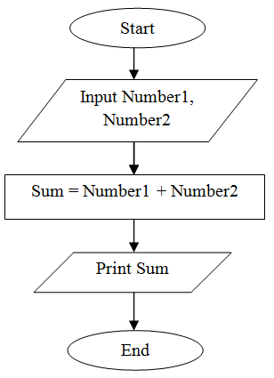

**6. What is Use case Diagram? Create a use-case on bill payment on paytm.**

**ANS.** Use Case Diagram is a type of Unified Modeling Language (UML) diagram that represents the interaction between actors (users or external systems) and a system under consideration to accomplish specific goals. It provides a high-level view of the system’s functionality by illustrating the various ways users can interact with it.

